Name: | ___________________________________________________ |  |  |  |  | Date: ___________
 | Subject - Year 8 Mathematics  Investigation 1, 2013  Topic – Perimeter & Area  In class component |  |  |  |  | 43  = %
Total Time: | 60 minutes
Reading Time: | 5 minutes
Working Time: | 55 minutes
Weighting: | 5% of the year.
Equipment: | Scientific Calculator
Date out: |  | Week ____ Date _____________ |  | Date Due: | Week ____ Date _____________
Take home component weighting: |  | 0% of the year |  | In-class component weighting: | 5% of the year.
AIM: In this assessment, you will be investigating area and perimeter for simple and composite shapes.
There are two parts to this assessment:
Item | Purpose | Marks available
Take-Home | To expand your knowledge and skill with Perimeter and Area. | None
In-Class | To test your knowledge and skill with Perimeter and Area. | 41
Bonus | Sheet of notes prepared during take-home phase | 2
 | Total | 43

This In-Class part is to be completed in class and you have one session to complete it. It will be run under exam conditions, in the same manner as exams and assessments in future years, in order that you become accustomed to them.

You are permitted the following:
- One A4 Sheet of notes (front and back)
- A scientific calculator
- Normal writing instruments
You will not be permitted to borrow equipment from others during the assessment.

You are not permitted to use your Take-Home part in the In-Class Verification

Please make sure you are using the appropriate units and show your working. In order to get maximum marks on this assignment, you must show working and use the correct units.

1. | Perimeter of a rectangle [7 marks: 1, 1, 2, 3]
 | Miranda’s bedroom is 5m x 4m x 2.5m high, with a doorway 1m wide and 2 m high in one of the 4m sides.
a) | Sketch a floor plan of Miranda’s room
b) | Add the appropriate dimensions to the floor plan of Miranda's room.
c) | Calculate the perimeter of the room so that Miranda can fit sealing material where the ceiling and walls meet.
d) | Calculate the amount of skirting board needed if Miranda is to fit skirting board where the walls and floor join.

2. | Perimeter of a circle [5 marks: 2, 3]
 | Miranda decides to add a circular mat.
a) | What is the diameter of the largest mat to fit the room?
b) | Miranda wishes to add an extra strip around the perimeter to protect the edge of the carpet. How much edging material does Miranda need?
3 | Tiled rectangles [ 6 marks: 2, 1, 1, 1, 1]
 | Miranda has a very small kitchen 2m x 3m x 2.5m high and wishes to tile the floor using 200mm square tiles.
a) | What is the area of each tile?
 | (i) in 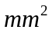
 | (ii) in 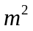
b) | How many tiles are needed along the long wall?
c) | How many tiles are needed along the short wall?
d) | How many tiles are needed altogether?
e) | What is the total tiled area?
4 | Area of square carpet [ 3 marks: 2, 1]
 | Miranda decided to try a square carpet in her 5m x 4m bedroom.
a) | What are the length and width of the maximum size of carpet that she could use? | Length ________ m  Width ________ m
b) | What is the area of this carpet?
5 | Area of rectangular carpet [ 3 marks: 2, 1]
 | Miranda decided to try a rectangular carpet in the bedroom.
a) | What are the maximum length and width of carpet that she should use? | Length _________ m  Width __________ m
b) | What is the area of this carpet?
6 | Area of a circular carpet [2 Marks]
 | Miranda wanted to try the circular carpet used previously in the perimeter question (Question 2)
 | What is the area of the circular carpet?
7 | Area of right angle triangle [ 3 marks]
Miranda wants a shade sail as shown below

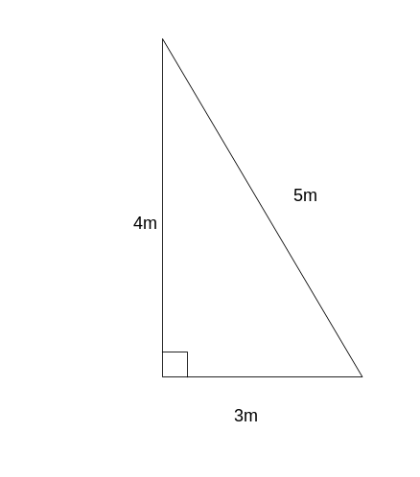

 | Calculate area of the material need to make the shade sail?
8. | Area of non-right triangle [3 marks]
Miranda decides to use a design like the one below.
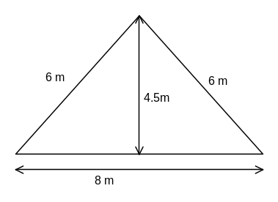
 | Calculate the area of material used.
9. | Area of rectangle with rectangle removed [6 marks: 2, 1, 1, 1, 1]
 | Miranda decides to turf the back yard which is 15m x 12m and includes a fish pond in the centre measuring 2.4m x 2m
a) | Draw a sketch plan of the yard
b) | Mark all dimensions you have been given on your plan.
c) | Calculate the area of the yard?
d) | Calculate the area of the pond?
e) | Calculate the area of turf needed?
10. | Rectangle with circle removed [3 marks: 2,1]
Miranda decides to have a circular fish pond of diameter 2.4 m instead.
(The back yard is still 15m x 12m. )
a) | Calculate the area of the pond
b) | Calculate the area of lawn left after the pond is dug out.

